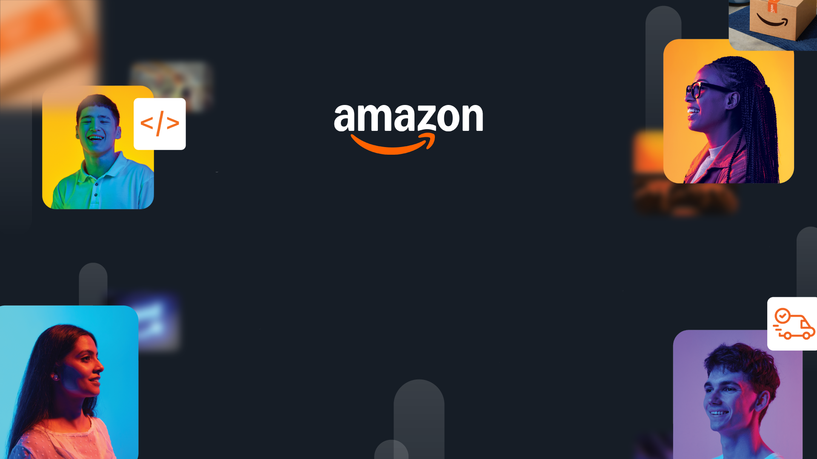

HackOn with Amazon
A Universe of Opportunity
48-Hour Hackathon | Solution Document

Team Name | 2 Peas in a Pod
Hackathon Theme | Second Life Commerce: AI-Powered Returns and Sustainable Resale
Date | 15 June 2026

Team Members
Name | College / University | Role | Email
Samarth Chatli | Thapar University | AI / CV and Frontend | schatli_be23@thapar.edu
Udai Batta | Thapar University | Backend, Infra and DevOps | ubatta60_be24@thapar.edu

1. Problem Statement & Relevance

The Problem
Online returns do not fail at checkout. They fail at the warehouse. Every returned item is shipped back to a facility before it can be resold, not because the warehouse adds value, but because it is the only place anyone currently trusts to confirm the item's real condition. That single trust step turns a refund into a 2 to 6 week round trip that often costs more than the product itself. In the US alone, returns move roughly 743 billion dollars of merchandise a year (NRF, 2023), and processing one return runs about 25 to 40 dollars in reverse logistics.

Why It Matters
This hits everyone in the chain. Shoppers wait weeks for refunds, retailers carry a cost center that often exceeds the item's resale value, and the planet absorbs the waste, an estimated 9.6 billion pounds of returned goods reach US landfills every year (Optoro). The rational response has become "keep it, here is your refund," which quietly trains return fraud now estimated at 80 to 100 billion dollars a year. Doing nothing means the cost, the fraud, and the waste all compound as e-commerce keeps growing.
→ Tip: Show global scale. Problems affecting millions score higher than niche issues.

Theme Alignment
HackOn is about building on Amazon's universe of assets, and returns is one of its largest hidden costs. Amazon already owns every piece this needs: delivery-time photos that can act as a product fingerprint, the Flex network for local pickup, Amazon Renewed for resale demand, and Bedrock for the AI. Our angle is simple. We do not build another marketplace on top of the broken loop. We use what Amazon already has to remove the warehouse from the loop entirely.

What Makes This Novel
Every existing player optimizes a piece of the return loop. Liquidators dump value, resale apps push risk onto the buyer, and returns software polishes the UX but still ships to a warehouse. Nobody questions the core assumption that inspection has to happen at a facility. That was true in 2010. Multimodal AI made it false in 2024. Our insight is that the warehouse is really a trust machine, and trust can now be created at the doorstep. Once it is, the return never has to travel back. Returns become transfers.

2. Customer & Solution

Target Customer
Asha just wants her refund without the drive to a drop-off and the three week wait. Rohan, a few kilometers away, wants the same headphones used and cheaper but will not gamble on a stranger's photos. The retailer wants the 30 dollar trust cost gone and the fraud stopped. RELAY serves all three at once: the doorstep becomes the inspection point, and the return becomes a verified local sale.

How We Solve It
RELAY runs an AI inspection at the customer's door, proves the item is the exact unit that was delivered, grades its condition, screens for fraud, and routes it straight to a nearby buyer with a trust certificate attached. No warehouse, no relisting, no weeks of value decay.
- Guided AI scan and fingerprint check. The camera walks the user through each angle and verifies the exact unit against its delivery-day fingerprint (image embedding, perceptual hash, and serial number).
- AI grading and a live fraud screen. A vision model finds the defects, a fixed rubric turns them into a grade and a certificate, and any serial or identity mismatch trips an instant fraud interrupt. AI perceives, rules decide.
- Direct buyer routing. The graded item is matched to the closest waiting buyer and shipped door to door, so the item never touches a warehouse.

User Workflow
Scan at the door > Verify and grade > Match and ship to a nearby buyer. Step 1: Asha opens the return and the AI guides a 60 second scan, redirecting her when a view is wrong. Step 2: RELAY confirms identity against the delivery-day fingerprint, detects defects, and mints a grade certificate, screening for fraud in the same pass. Step 3: the disposition engine routes the verified item to the best-fit buyer nearby, who reserves it and confirms on delivery. (Insert the 3 step flow diagram here.)

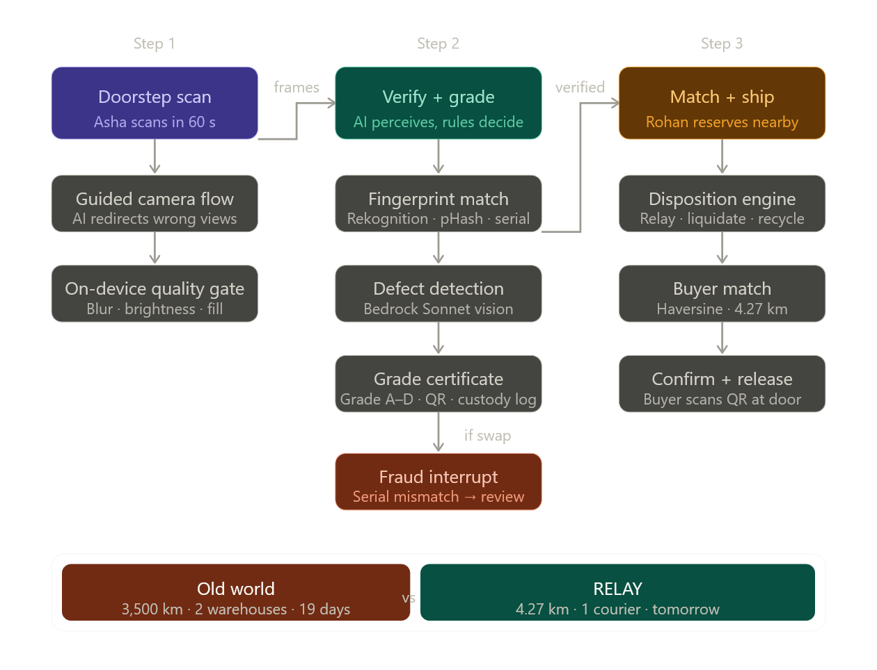

Working Prototype
Working end to end today across three surfaces: a seller app, a buyer app, and a live ops dashboard. The doorstep scan, fingerprint match, AI grading certificate, fraud interrupt, buyer map, and the final journey screen all run on real calls, with a cached fallback so the demo never breaks offline. (Insert 2 to 3 screenshots: the grade certificate, the red fraud interrupt, and the buyer map.)
Demo: Video to be added
.

3. Tech Architecture & Scaling

Architecture
RELAY is event driven. A React frontend talks to a FastAPI core whose service modules (scan, fingerprint, defects, grading, pricing, fraud, matching, disposition) each map one to one onto a future AWS service. Every state change emits an event onto a bus and appends to an append-only custody ledger, and the ops dashboard subscribes over a live stream. The AI layer sits behind a fallback ladder, so a slow or failed model call drops to a cached result, then to a rule-based stub, and never to an error screen. The monolith we built this weekend is the production system with the network calls removed. (Insert the system architecture diagram here.)

Tech Stack
Layer | Technology | Why
Frontend | React, Vite, Tailwind, Framer Motion, Leaflet | Seller app, buyer app, and a dark ops dashboard in one codebase; runs offline for a stable live demo.
Backend | FastAPI, Pydantic, Server-Sent Events | Async, typed service modules that mirror the target AWS services, with an event bus and an append-only custody ledger.
Data/ML | Gemini Flash vision, local CLIP-style embeddings, perceptual hash, deterministic rubric | Real defect detection and identity matching at zero cost, swappable to Bedrock and Titan in production.
Infra | One container now; AWS path: Step Functions, EventBridge, SQS, DynamoDB, OpenSearch, S3, CloudFront | Stateless compute behind queues with managed state, so scaling is a config change, not a rewrite.

Key Algorithms & Complexity
Identity is a weighted composite: cosine similarity of image embeddings (0.35), perceptual hash Hamming distance (0.20), and an exact serial match (0.45). Each comparison is O(d) over a short vector and O(n) over the candidate set today, and becomes sublinear with an OpenSearch k-NN index at scale. Grading is deterministic: the model extracts defects, then a severity weighted rubric maps them into A to D bands, so the same item always earns the same grade. This is our core principle, AI perceives, rules decide. The trust score blends identity with behavioral signals (return frequency, time since delivery, reason versus defect consistency) and routes anything below threshold to human review. Buyer matching is a haversine geo query ranked by distance and price fit.
→ Show thought leadership: novel combinations, creative use of algo/tech, not just standard CRUD.

Scaling Strategy
Everything stateful is managed (DynamoDB, S3, OpenSearch) and everything compute is stateless (Lambda behind SQS), so handling 100x to 1000x more returns is a quota request, not a redesign. Bedrock absorbs the model load, queues and dead letter queues absorb spikes, presigned uploads keep images off the API path, and cached results with pre-warmed models keep latency flat. Cost is pay per return with near zero idle, which matches a workload that spikes after every holiday.
→ Solutions restricted to local functionality score low. Show global scalability.

4. Future Vision

Where This Goes
In one to three years RELAY is not an app, it is infrastructure: the trust and routing layer underneath reverse commerce. The same certificate that verifies one return becomes a neutral standard that any retailer, marketplace, carrier, or insurer can plug into. Think of it as the UPI for second-life commerce, a shared rail that makes a used item as trustworthy as a new one, anywhere.

Roadmap
Horizon | Milestone | Impact
0-3 mo | Fraud-screen and grading API for D2C brands, no logistics required | First paying brands; thousands of items graded; data flywheel starts.
3-6 mo | Doorstep grading and peer relay routing live in one city, with carrier pickup | First warehouse-free transfers; real demand density in a launch city.
6-12 mo | Trust API and cross-marketplace certificates; pricing trained on real resale outcomes | Multi-retailer adoption; verified second-life pricing at scale.

Multi-Segment Expansion
We start where AI grading is most reliable, electronics and hard goods, then move into apparel as the models improve. The customer path widens the same way: D2C brands first because they feel returns pain hardest and need no logistics, then marketplaces, then carriers who can grade at pickup, then insurers who can price returns risk off our data. Each step is independently useful, and each one feeds the next.

Value Impact
Returns are a 743 billion dollar flow with 25 to 40 dollars of reverse logistics on every item, plus 80 to 100 billion dollars in annual fraud and billions of pounds of landfill. RELAY attacks all three. At Amazon's scale, saving even 5 dollars per return is a billion dollar line, before counting recovered resale value, fraud stopped, and the kilometers and carbon removed from every journey. The headline stays the same: the item never touched a warehouse.

Links: GitHub https://github.com/UdaiBatta/Amazon-Hack-On | Demo Video to be added | Live App to be added

